

**PYTHON LAB**

**ASSIGNMENT**

NAME : Bapan Ghosh

STUDENT ID : 201001270057

Stream.: MCA(first semester)

DATE OF SUBMISSION : 24/02/2021

Q 1. write a program to remove vowels from a given string

**CODE :**

n="bapan ghosh "

vowel='a' or 'A' ,'e' or 'E', 'i' or 'I', 'o' or 'O' , 'u' or 'U'

for i in n:

if i in vowel:

n=n.replace(i,"")

print(n)

**OUTPUT :**

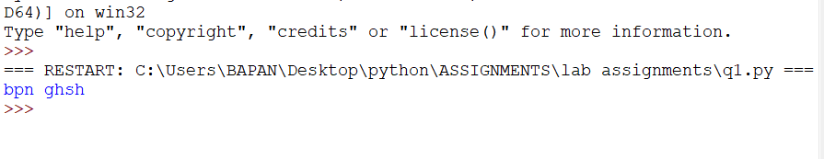

Q 2. write a program to implement count() function

**CODE :**

l=[20,60,80,70,40,70]

print(l.count(70))

**OUTPUT :**

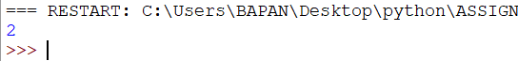

Q 3. Write a program to check given pan no is valid

or not in python

**CODE :**

pan = input("Enter the PAN card no: ")

if len(pan) == 10 and pan[0:5].isalpha() and pan[0:5].isupper() and pan[5:9].isdecimal() and pan[9].isupper():

print("It's a Valid PAN card")

else:

print("It's an Invalid PAN card")

**OUTPUT :**

